Project Title
Network Port Scanner

Internship Organization:
SAM AI Technologies

Duration:
1 Months Internship

Year: 2026

Project Report Submitted By
Name: Arshi

Introduction of 3 Tool: Network Mapper (NMAP) is an industry-standard, open-source network scanner and security auditing tool designed to explore computer networks and evaluate host security. It works by transmitting specialized raw data packets across IP networks to discover active hosts, locate listening (open) or closed ports, detect running services alongside their exact version numbers, and identify remote operating systems. In cybersecurity, NMAP serves as a fundamental reconnaissance framework used by security engineers and system administrators to audit attack surfaces, verify firewall defenses, and maintain comprehensive network visibility.
Important Points of NMAP Tool
- Full Form: NMAP stands for Network Mapper.
- Open Source: It is a free and open-source tool used for network discovery and security auditing
- Origin: It was created by Gordon Lyon (Fyodor) and first published in 1997.
- Cross-Platform: It runs seamlessly on Linux, Windows, and macOS operating systems.
- Industry Standard: It is utilized by both ethical hackers and cybersecurity professionals for network protection and vulnerability assessment.
Scan a target IP or local host
Target IP Scan (target-IP): Probes an external or networked machine by its IP address to identify active network interfaces, listening services, and potential vulnerabilities from outside that host.
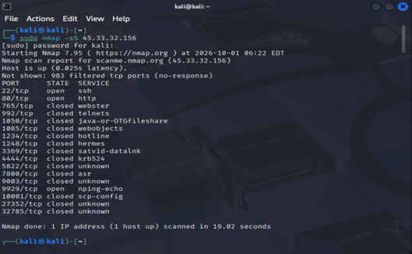

Target-IP Scan Results (45.33.32.156 / scanme.NMAP.org)
The scans directed at the external target IP (45.33.32.156) probed common TCP ports over the internet to map exposed network services:
- Host Status: The target is alive and responsive, with a network latency between 0.025s and 0.034s.
- Discovered Open Ports:
  - 22/tcp (open - ssh): An OpenSSH service is actively running and accepting remote terminal connections. This means administrators can log in remotely via SSH.
  - 80/tcp (open - http): An active web server is accepting unencrypted HTTP traffic.
  - 9929/tcp (open - nping-echo): The Nping echo server is running and actively listening for Nping probes.
- Closed Ports: Ports like 765/tcp, 992/tcp, 1050/tcp, etc., returned a TCP RST (reset) packet. This confirms the host received the probe, but no server program is currently listening on those port numbers.
- Filtered Ports: Over 970+ ports were reported as filtered (no-response). This means an upstream firewall, security rule, or packet filter silently dropped the probe packets, preventing NMAP from verifying whether those ports are open or closed.
Localhost Scan (localhost or Target IP): Probes your own computer via the internal loopback interface to audit locally listening software, verify firewall rules, and catch unintended background services before exposing them to the network.
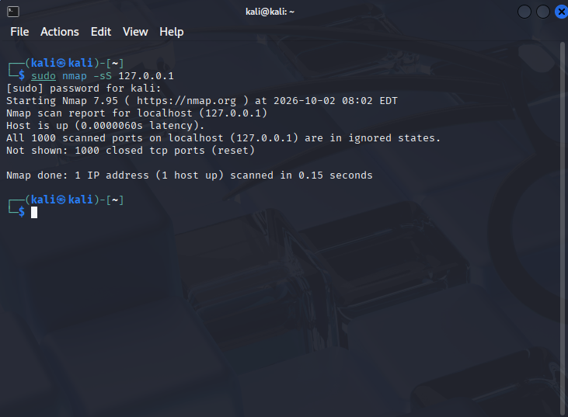

Localhost Scan Results (127.0.0.1 / localhost)
The scan executed against localhost checked the internal loopback adapter on your own machine:
- Host Status: The local host was reached almost instantaneously with an extremely low latency of 0.000013s.
- Scanned Ports Status:
  - All 1,000 scanned TCP ports reported:
All 1000 scanned ports on localhost (127.0.0.1) are in ignored states.
Not shown: 1000 closed tcp ports (reset)
- Security Meaning:
  - Your local Kali Linux system returned TCP RST packets for every scanned port.
  - This confirms that no unauthorized background server applications (like local web servers, FTP, or databases) are currently listening or exposed on default ports, meaning the local operating system has a clean, unexposed footprint.
Key Comparison
Feature | Target IP (45.33.32.156) | Localhost (127.0.0.1)
Scan Type | Remote network scan | Internal loopback scan
Active Services | Multiple exposed services (SSH, HTTP, Nping-Echo) | None (Zero open services detected)
Firewall Presence | Active firewall filtering (970+ filtered ports) | No filtering observed (direct TCP resets returned)
Audit Conclusion | External attack surface exists via web and remote shell. | No open ports where detected among the 1000 TCP ports scanned on localhost.

-sS (TCP SYN Scan): The standard stealth scan that sends SYN packets without completing the full TCP 3-way handshake, making it fast and efficient for discovering open ports.
Detect Open Ports Using Nmap
Detect open port: A network reconnaissance probe that queries communication endpoints to determine which services are actively accepting connections.
Primary Use: Identifies running services, verifies firewall effectiveness, and maps the attack surface by displaying only ports reported as open and displaying only live, accessible entry points.
Core Flag (--open): Filters out noise (closed and filtered states) so the output lists only active listening ports.
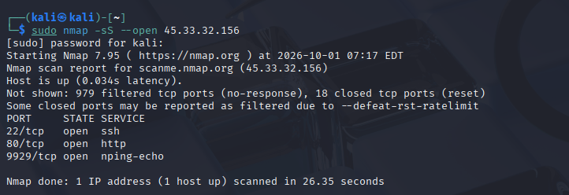

Display port number and status
Definitions & Uses
Field | Definition | Primary Use
Port Number | A 16-bit numerical identifies (1–65535) assigned to a specific communication channel and network protocol (TCP/UDP). | Directs incoming network traffic to the correct application or service running on a host.
Port Status | The operational condition of a port determined by how it responds to network probes (open, closed, or filtered). | Assesses accessibility, verifies firewall filtering rules, and maps the attack surface.
NMAP Mapping | The process of probing network endpoints, correlating responses to known service signatures, and displaying the results. | Audits network boundaries, validates security policies, and discovers active network assets.

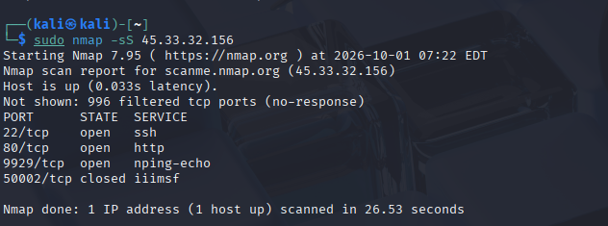

Allow custom port range
Definitions & Use
Feature |  |  | Definition | Primary Use
Custom Port Range |  |  | A user-defined subset of ports (e.g., 8000-8080) specified instead of scanning or opening all 65,535 ports. | Focuses scans on application-specific services (e.g., web dev, high-range proxies) to save scan time and
NMAP Mapping (-p <start>-<end>) |  |  | Instructs NMAP to probe strictly within the chosen numeric boundary. | Targets non-standard or custom listening ports without
Firewall Allowance (ufw allow / iptables) | Creates a packet-filtering rule permitting inbound traffic across the defined boundary. | Creates firewall rules that allow traffic to the specified ports when required by the application.
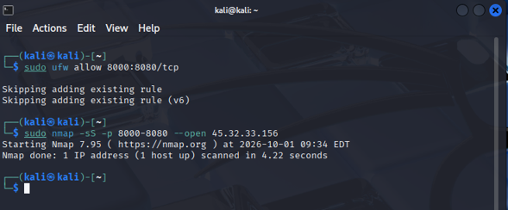
Generate scan summary
Definitions & Use
Feature | Short Definition | Primary Use
Scan Summary | A concise post-scan report displaying host status, discovered services, execution duration, and packet statistics. | Provides a high-level overview for auditing, performance tracking, and quick triage without digging through raw logs.
NMAP Mapping Tool | A network exploration and auditing engine that sends raw probes to identify live hosts, open ports, and running software. | Discovers active network infrastructure, catalogs services, and maps security boundaries.
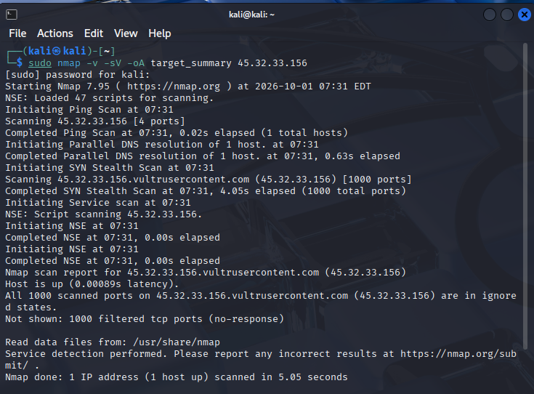

Security Findings & Scan Analysis
During the practical execution of network reconnaissance using NMAP against the target IP (45.33.32.156) and localhost, the following technical observations were recorded:
- Target IP Surface Exposure (45.33.32.156):
  - Port 22/tcp (open - SSH): Port 22/tcp is open and an SSH service is detected. The SSH configuration and authentication controls should be reviewed.
  - Port 80/tcp (open - HTTP): Indicates an active web server accepting unencrypted HTTP traffic. In a hardened environment, traffic should be redirected to secure HTTPS (port 443).
  - Port 9929/tcp (open - nping-echo): An open echo service actively accepting connections. Unnecessary network diagnostic services should be disabled to reduce the attack surface. 0
- Firewall Behavior & Filtered Ports:
  - The scan reported over 970+ ports in a filtered state, indicating that an intermediate firewall or packet filtering mechanism is dropping unauthorized connection attempts.
- Localhost Audit (127.0.0.1):
  - All 22,80,9929 scanned ports on localhost reported in a closed state (reset received), verifying that no rogue local listeners or exposed development services are running unprotected on the host system.
2. Conclusion
NMAP is an essential network mapping and vulnerability assessment tool that plays a critical role in proactive cybersecurity audits. Through this project, different scanning methodologies—including TCP SYN stealth scanning (-sS), target profiling, and custom port boundary enumeration—were successfully executed and analyzed.
Identifying open ports and the services running behind them is crucial for understanding an organization's perimeter security and attack surface. Periodic network scanning combined with strict firewall filtering policies ensures robust defensive posture and continuous security compliance across enterprise environments.
References : https://nmap.org/

